Earthquake modelling – Chennai

Data Source and credibility
The Earthquake dataset used in this study was obtained from the United States Geological Survey (USGS - USGS Earthquake Catalog). USGS is a globally recognized scientific body that is responsible for monitoring and reporting seismic activity through an extensive international network of seismograph.
The dataset is taken for the period 1976 to 2026. A custom rectangular region was defined to focus on India in particular and nearby regions
Latitude range: −2.944° to 40.346° - Longitude range: 55.525° to 101.931°
Minimum magnitude: 2.5 - Maximum magnitude: 10.0

Data insights
Following data summaries were prepared to understand and summarize seismic activities over the past 5 decades.
- A table of magnitude threshold exceedance counts
- A table of depth threshold exceedance counts
- A table of depth counts
- A table of year counts, observed earthquakes by year irrespective of the magnitude size

Magnitude Threshold exceedance counts
A table showing number of earthquakes count exceeding magnitude thresholds from 2.5 to 9 was generated from the data, year wise. This helped us understand certain key features of the distribution of earthquake magnitudes. A snippet of the table if provided below.
Magnitude Threshold Counts
Year | MAG Greater/Equal 6.5 | MAG Greater/Equal 7 | MAG Greater/Equal 7.5 | MAG Greater/Equal 8 | MAG Greater/Equal 8.5 | MAG Greater/Equal 9
2004 | 4 | 2 | 1 | 1 | 1 | 1
2005 | 12 | 3 | 2 | 1 | 1 | 0
2006 | 1 | 0 | 0 | 0 | 0 | 0
2007 | 4 | 2 | 1 | 0 | 0 | 0
2008 | 9 | 3 | 0 | 0 | 0 | 0
2009 | 5 | 2 | 2 | 0 | 0 | 0
2010 | 7 | 3 | 2 | 0 | 0 | 0
2011 | 4 | 1 | 0 | 0 | 0 | 0
2012 | 4 | 3 | 2 | 2 | 1 | 0
2013 | 3 | 2 | 2 | 0 | 0 | 0
2014 | 1 | 0 | 0 | 0 | 0 | 0
2015 | 7 | 4 | 2 | 0 | 0 | 0
2016 | 7 | 0 | 0 | 0 | 0 | 0

Earthquakes exceeding magnitude 9 were observed in 2004, corresponding to the Indian Ocean (Sumatra–Andaman) earthquake, one of the most powerful earthquakes ever recorded with an estimated magnitude of approximately 9.1–9.3.
Additionally, earthquakes exceeding magnitude 8.5 were identified in 2004, 2005, and 2012, aligning with documented major seismic events in the Indian Ocean region. The 2005 event corresponds to a major aftershock (~8.6) of the 2004 Sumatra–Andaman.
The 2012 Indian Ocean earthquake (~8.6) represents a rare large intraplate event. This earthquake occurred within the Indo-Australian plate rather than along a plate boundary and is widely recognized as one of the largest intraplate strike-slip earthquakes ever recorded
These observations are consistent with historical records, where extreme magnitude earthquakes are rare and typically associated with large tectonic plate boundary ruptures.
Sources: Sumatra-Andaman Earthquake - USGS - 2004 Indian Ocean earthquake and tsunami - Wikipedia - 2012 Indian Ocean earthquakes - Wikipedia

Depth Threshold Exceedance Counts
Most earthquakes don’t occur at great depths because rocks deep inside the Earth are too hot and ductile to break suddenly. Earthquakes require brittle failure, which is only possible in the cooler, rigid crust and upper mantle. This behaviour is captured in the data. A snippet of the table is provided below.
Depth Threshold Counts
Year | Depth Greater/Equal 0 | Depth Greater/Equal 40 | Depth Greater/Equal 80 | Depth Greater/Equal 120 | Depth Greater/Equal 160
2000 | 691 | 273 | 202 | 132 | 82
2001 | 854 | 322 | 240 | 162 | 93
2002 | 936 | 290 | 222 | 157 | 113
2003 | 825 | 209 | 164 | 102 | 65
2004 | 1646 | 511 | 247 | 140 | 84
2005 | 5967 | 594 | 253 | 156 | 113
2006 | 2025 | 507 | 296 | 189 | 124
2007 | 1597 | 595 | 396 | 255 | 168
2008 | 2731 | 753 | 497 | 311 | 191
2009 | 846 | 222 | 110 | 53 | 31
2010 | 856 | 286 | 119 | 51 | 28
2011 | 758 | 310 | 123 | 62 | 41
2012 | 1396 | 329 | 146 | 78 | 54
2013 | 1191 | 407 | 220 | 132 | 84
2014 | 1251 | 455 | 251 | 164 | 98
2015 | 1360 | 444 | 306 | 208 | 144
2016 | 1025 | 411 | 295 | 173 | 117

Year | Depth Greater/Equal 200 | Depth Greater/Equal 240 | Depth Greater/Equal 280 | Depth Greater/Equal 320 | Depth Greater/Equal 360
2000 | 55 | 6 | 2 | 0 | 0
2001 | 52 | 5 | 2 | 0 | 0
2002 | 89 | 4 | 0 | 0 | 0
2003 | 46 | 5 | 0 | 0 | 0
2004 | 37 | 9 | 0 | 0 | 0
2005 | 46 | 5 | 1 | 0 | 0
2006 | 43 | 9 | 0 | 0 | 0
2007 | 97 | 10 | 0 | 0 | 0
2008 | 94 | 6 | 1 | 0 | 0
2009 | 14 | 1 | 0 | 0 | 0
2010 | 16 | 4 | 0 | 0 | 0
2011 | 18 | 1 | 0 | 0 | 0
2012 | 25 | 2 | 0 | 0 | 0
2013 | 54 | 4 | 0 | 0 | 0
2014 | 55 | 5 | 0 | 0 | 0
2015 | 91 | 5 | 1 | 0 | 0
2016 | 71 | 7 | 3 | 0 | 0

Depth and Year Counts
A notable increase in earthquake counts is observed during 2004–2005, driven by aftershocks following the 2004 Sumatra–Andaman earthquake. This highlights dependencies between 2 seismic activities (we however assume that earthquake counts follow independent Poisson Distribution to simplify our model). A snippet of the depth count and year wise earthquake count tables are provided below.
Year | Shallow (<70 km) | Intermediate (70–300 km) | Deep (>300 km) | Total EQs
2000 | 477 | 213 | 1 | 691
2001 | 595 | 259 | 0 | 854
2002 | 697 | 239 | 0 | 936
2003 | 652 | 173 | 0 | 825
2004 | 1359 | 287 | 0 | 1646
2005 | 5695 | 272 | 0 | 5967
2006 | 1697 | 328 | 0 | 2025
2007 | 1166 | 431 | 0 | 1597
2008 | 2205 | 526 | 0 | 2731
2009 | 720 | 126 | 0 | 846
2010 | 723 | 133 | 0 | 856
2011 | 609 | 149 | 0 | 758
2012 | 1221 | 175 | 0 | 1396
2013 | 953 | 238 | 0 | 1191
2014 | 975 | 276 | 0 | 1251
2015 | 1037 | 322 | 1 | 1360

Charts
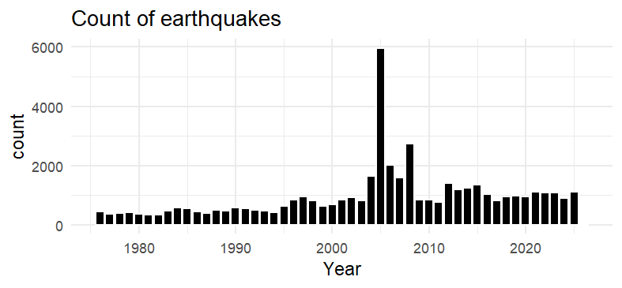
Figure 1 Annual earthquake counts exhibit an increasing trend over time, primarily driven by improvements in technology, leading better earthquake detection (not necessarily due to an increasing EQ counts). A significant spike is observed during 2004–2005 due to aftershock following the 2004 Sumatra-Andaman EQ.
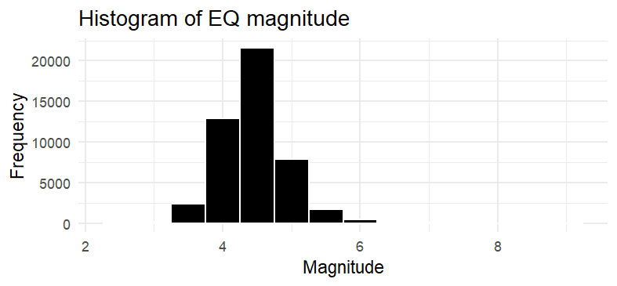
Figure 2 The majority of earthquakes concentrated in the 4–5 magnitude range. The frequency of events declines as magnitude increases.
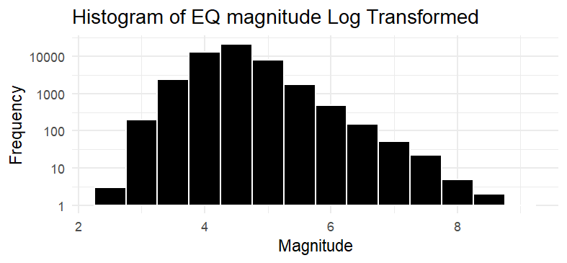
Figure 3 When plotted on a logarithmic scale, the magnitude distribution exhibits an approximately linear decline, consistent with the Gutenberg–Richter law. logN(M)=a−bM, where N(M) is the number of earthquakes with magnitude ≥𝑀
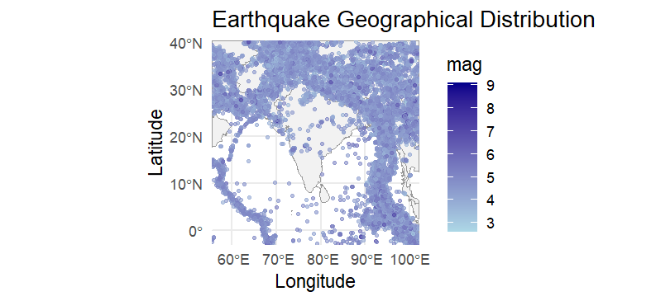
Figure 4 The longitude and latitude values in the dataset represent the epicenters of earthquakes. Most of India lies in a stable tectonic region, not on active plate boundaries. The Himalayan region is an active collision zone and the Andaman-Sumatra, a subduction zone. As a result, we can see a lot of points clustered around the Himalayan belt and around Indonesia (Andaman-Sumatra Zone).
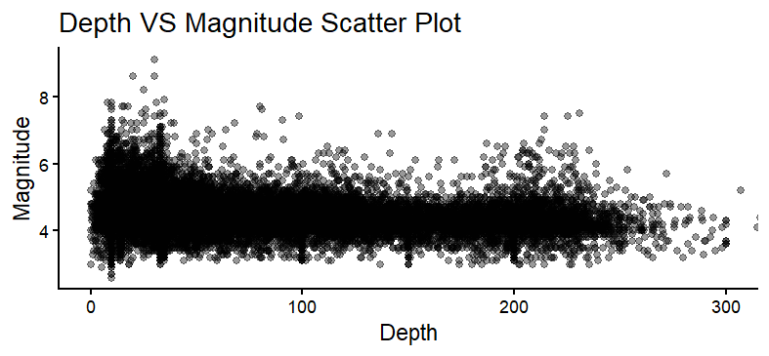
Figure 5 Depth and Magnitude are uncorrelated
The correlation between depth and magnitude is 0.1, suggesting that they are uncorrelated.
> cor(EQ$depth, EQ$mag)
[1] -0.1274916

Gutenberg–Richter law
The Gutenberg–Richter law expresses the relationship between the magnitude and total number of earthquakes in any given region and time period of at least that magnitude.
$$\log_{10}{N\left(M\right)=a-bM}$$
$$N\left(M\right)={10}^{a-bM}$$
$N(M)$ is the number of earthquakes have magnitude at least M
$a$ and $b$ are constants

Simulating Earthquakes
The dataset spans for five decades, which may be insufficient to reliably estimate the occurrence of rare, high-magnitude events. As a result, direct use of historical data can lead to incorrect estimates. For example, an event observed once in the dataset may be interpreted as having a frequency of approximately 1 in 50 years. This may not accurately reflect its true long-term occurrence rate. To overcome this limitation, a simulation-based approach is adopted to generate a dataset that preserves the underlying distribution of observed events.
We first identify the magnitude above which our dataset is reliable. According to Gutenberg–Richter law, the log transformed counts of earthquake occurrences is linearly related to the magnitudes.
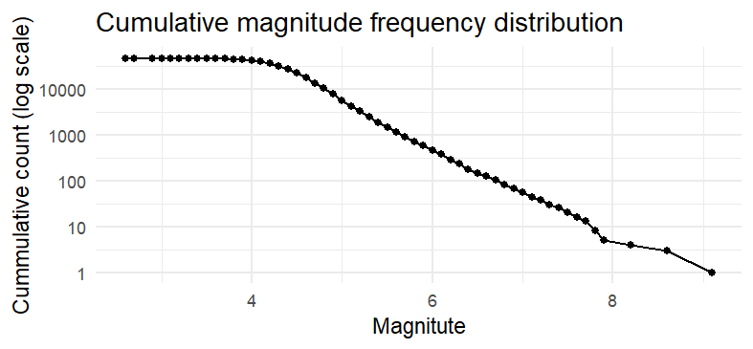
Figure 6 Linear relationship between log transformed occurrence counts and magnitude is observed from around magnitude 4.2
The above chart reveals that the linear relationship dictated by the Gutenberg-Richard Law is observed from a magnitude of 4.2. Below 4.2, the earthquakes are not sufficiently detected, due to their low intensity. In order to prevent the earthquakes belonging to magnitudes that are not sufficiently recorded from impacting our analysis, we simply remove them.
####Below what magnitude is my data unreliable?####
mag_bins = seq(floor(min(EQ$mag)), ceiling(max(EQ$mag)), by = 0.1)

mag_cum = EQ %>% mutate(mag_bin = floor(mag*10)/10) %>% count(mag_bin) %>% arrange(desc(mag_bin)) %>% mutate(cum_count = cumsum(n))

ggplot(mag_cum, aes(x = mag_bin, y = cum_count)) +
geom_point() +
geom_line() +
scale_y_log10() +
labs(
title = "Cumulative magnitude frequency distribution",
x = "Magnitute",
y = "Cummulative count (log scale)"
) +
theme_minimal()

Mc <- 4.2 #lets remove magnitude below 4.2 because many low magnitude earthquakes are missing from observations.

EQ_model = EQ %>% filter(mag >= Mc)

Earthquake frequency was modelled using a Poisson distribution, under the assumption that events occur independently over time with a constant average annual rate. The annual event count was estimated from historical data. It was used to simulate the number of earthquakes in each of 1,000 years.
Earthquake magnitudes were simulated using bootstrap sampling from the observed historical magnitudes. This preserves the empirical magnitude distribution. Depth, latitude, and longitude, were similarly assigned by resampling from historical records.
lambda_hat = mean(yearly_model_count$n)
lambda_hat

####Simulation of earthquakes####
n_years = 1000
set.seed(123)
n_events_per_yesr = rpois(n_years, lambda_hat)
head(n_events_per_yesr)

#Simulate magnitude for each year and each earthquake from that year

simulated_events = data.frame()

for(i in 1:n_years) {
n_events = n_events_per_yesr[i]
if(n_events == 0) next
mags = sample(EQ_model$mag, n_events, replace = TRUE)

#sample location and depth from the actual data

sample_rows = EQ_model %>% sample_n(n_events, replace = TRUE)

temp = data.frame(
Year = i,
mag = mags,
longitude = sample_rows$longitude,
latitude = sample_rows$latitude,
depth = sample_rows$depth
)
simulated_events = rbind(simulated_events, temp)
}

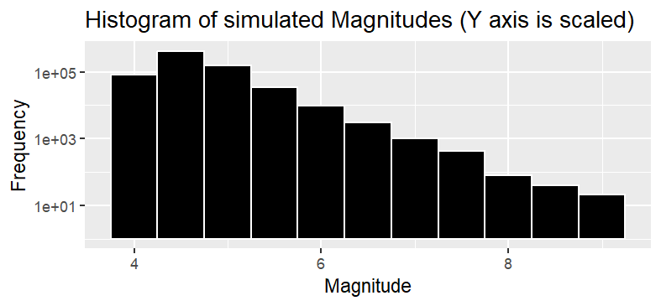
Figure 7 The Log of count of earthquakes for the simulated data shows linearly declining trend, consistent with the Gutenberg-Richter Law

Modelling PGA in Chennai
The USGS earthquake dataset does not contain Peak Ground Acceleration (PGA), and hence PGA was estimated using an attenuation relationship.
An empirical attenuation model developed by M. L. Sharma (1998) for the Indian Himalayan region was used, which relates PGA to earthquake magnitude and hypocenter distance (source: PGA Model by M.L.Sharma). The proposed equation is:
$$\log\left(A\right)=-1.072+0.3903M-0.21*log⁡(X+e^{0.5873M})$$
$A$ = PGA
M = Magnitude
X = Hypocenter distance
Several alternative GMPEs have been developed for the Indian subcontinent, including those by Iyengar and Ghosh (2004), and Anbazhagan et al. (2013), using regional seismic data.
More recent open-access studies, such as Dadhich et al. (2024), also propose GMPEs based on Indian strong-motion datasets
Sources: Microzonation of earthquake hazard - Soil Dynamics and Earthquake Engineering - Anbazhagan - Ground motion prediction equation - Harendra K. Dadhich
> ####Modeling PGA in Chennai, India####
> #Approximate latitude and longitude of Chennai
> site_lon <- 80.2707
> site_lat <- 13.0827
>
> #epicenter distances from Chennai in KM
> simulated_events$distance_km = distHaversine(
+ matrix(c(simulated_events$longitude, simulated_events$latitude), ncol = 2),
+ c(site_lon, site_lat)
+ )/1000
>
> simulated_events$HC_distance = sqrt(simulated_events$distance_km^2 + simulated_events$depth^2)
>
> #Simulating PGA
> compute_pga = function(M, X) {
+ log10_A = -1.072 + 0.3903 * M - 1.21 * log10(X + exp(0.5873 * M))
+ A = 10^(log10_A)
+ return(A)
+ }
> simulated_events$PGA = compute_pga(simulated_events$mag, simulated_events$HC_distance)
> summary(simulated_events$PGA)
Min. 1st Qu. Median Mean 3rd Qu. Max.
0.0001704 0.0003391 0.0004495 0.0005419 0.0006169 0.0619834
> ggplot(simulated_events, aes(PGA)) +
+ geom_histogram(bins = 50, fill = "black", color = "white") +
+ scale_x_log10() +
+ theme_minimal()
> #Maximum PGA for the year
> annual_max_pga = simulated_events %>% group_by(Year) %>% summarise(MAX_pga = max(PGA,na.rm = TRUE)) %>% ungroup()
>
> summary(annual_max_pga$MAX_pga)
Min. 1st Qu. Median Mean 3rd Qu. Max.
0.002000 0.003728 0.005079 0.006509 0.007236 0.061983

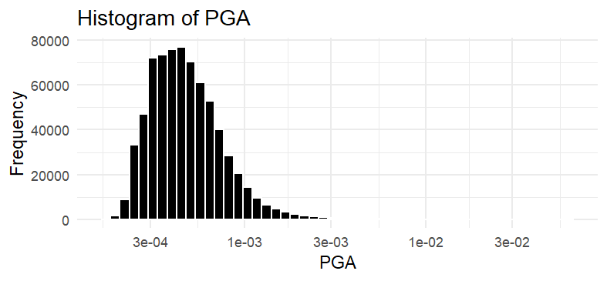

Hazard
The hazard curve was constructed by computing the proportion of events exceeding each of the maximum PGA level for the 1000 simulated years.
The hazard curve was obtained by plotting PGA against its corresponding annual exceedance probability, representing the likelihood of exceeding different levels of ground shaking.
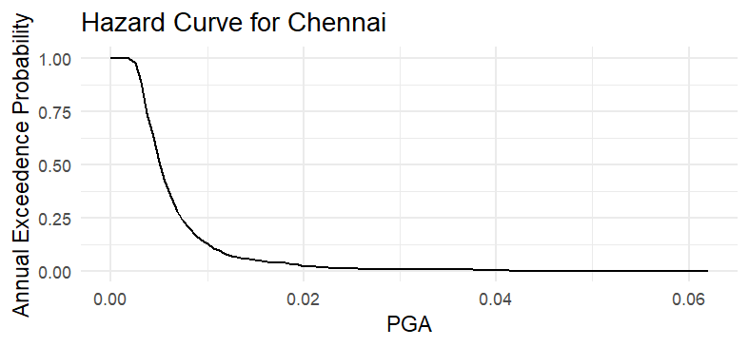
Figure 8 The hazard curve indicates that the probability of exceeding higher levels of ground motion decreases exponentially, with significant shaking (PGA > 0.02 g) occurring only at low annual probabilities.
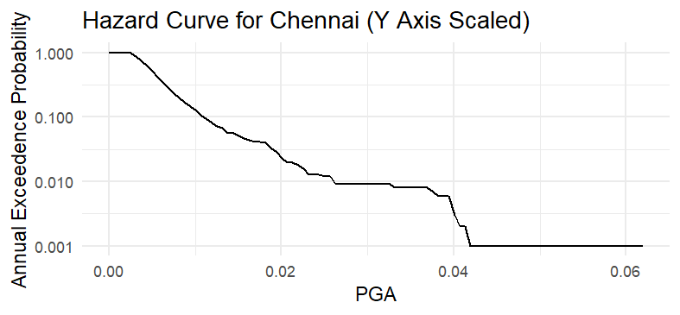
Figure 9 The hazard curve shows a linearly declining when viewed on a log scale. The tail appears thin and unstable due to the limited number of extreme events and absence of a variability term, leading to potential underestimation of tail risk.

Exposure
The exposure data was synthetically generated to represent a portfolio of buildings within the Chennai.
Building locations were randomly assigned, and attributes such as building type and asset value were simulated to create a simplified representation of exposure.
> #####Generated Exposure data#####
> set.seed(123)
> exposure = data.frame(
+ asset_id = 1:1000,
+ longitude = runif(1000, 79.8, 80.5),
+ latitude = runif(1000, 12.8, 13.3),
+ value = runif(1000, 10^5, 10^6),
+ building_type = sample(
+ c("Masonry", "RC"),
+ 1000,
+ replace = TRUE,
+ prob = c(0.65, 0.35)
+ )
+ )
> summary(exposure)
asset_id longitude latitude value
Min. : 1.0 Min. :79.80 Min. :12.80 Min. :103164
1st Qu.: 250.8 1st Qu.:79.98 1st Qu.:12.93 1st Qu.:310195
Median : 500.5 Median :80.14 Median :13.05 Median :546816
Mean : 500.5 Mean :80.15 Mean :13.05 Mean :548743
3rd Qu.: 750.2 3rd Qu.:80.32 3rd Qu.:13.17 3rd Qu.:771257
Max. :1000.0 Max. :80.50 Max. :13.30 Max. :999686
building_type
Length:1000
Class :character
Mode :character
> table(exposure$building_type)

Masonry RC
644 356

Vulnerability
The vulnerability model was developed to map ground motion intensity (PGA) to expected damage for different building types.
Separate damage functions were defined for masonry and reinforced concrete structures.
Damage ratios were estimated as a function of PGA using a simplified relationship, with damage increasing non-linearly as PGA rises.
> #####Vulnerability Model#####
> #We’ll use a simple deterministic function returning damage ratio
> vulnerability_function = function(pga, building_type) {
+ if(building_type == "Masonry") {
+ if(pga < 0.005) return(0.00)
+ if(pga < 0.010) return(0.02)
+ if(pga < 0.020) return(0.08)
+ if(pga < 0.030) return(0.15)
+ if(pga < 0.050) return(0.30)
+ return(0.60)
+ }
+ if(building_type == "RC") {
+ if(pga < 0.005) return(0.00)
+ if(pga < 0.010) return(0.01)
+ if(pga < 0.020) return(0.04)
+ if(pga < 0.030) return(0.08)
+ if(pga < 0.050) return(0.18)
+ return(0.35)
+ }
+ }
>
> vulnerability_function(0.015, "Masonry")
[1] 0.08
> vulnerability_function(0.015, "RC")
[1] 0.04
>
> ####Annual Losses####
> #We assume that the max pga for the year is experienced uniformly across all assets in Chennai
>
> annual_loss = annual_max_pga %>% rowwise() %>% mutate(Portfolio_Loss = sum(sapply(1:nrow(exposure), function(i){
+ dr = vulnerability_function(MAX_pga, exposure$building_type[i])
+ exposure$value[i]*dr
+ }))) %>% ungroup()
>
> summary(annual_loss$Portfolio_Loss)
Min. 1st Qu. Median Mean 3rd Qu. Max.
0 0 9090489 9736515 9090489 282136563

Loss Exceedance Probability
The loss exceedance curve was constructed by evaluating, for each loss threshold, the proportion of simulated years in which the total annual loss exceeds that threshold.
The curve shows a steep decline in probability with increasing loss.
The Average Annual Loss (AAL) is estimated at approximately ₹9.7 million, while the tail of the distribution is heavy, with the 99th and 99.5th percentile losses reaching ₹69 million and ₹142 million respectively.
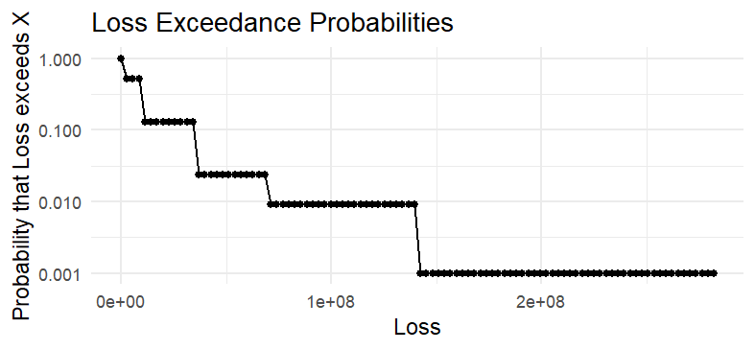
> loss_thresholds = seq(0, max(annual_loss$Portfolio_Loss), length.out = 100)
> loss_curve = data.frame(
+ Loss = loss_thresholds,
+ Exceed_prob = sapply(loss_thresholds, function(x) {
+ mean(annual_loss$Portfolio_Loss >= x)
+ })
+ )
>
> ggplot(loss_curve, aes(Loss, Exceed_prob)) +
+ geom_point() +
+ geom_line() +
+ scale_y_log10() +
+ theme_minimal() +
+ labs(
+ title = "Loss Exceedance Probabilities",
+ x = "Loss",
+ y = "Probability that Loss exceeds X"
+ )
>
>
>
> AAL = mean(annual_loss$Portfolio_Loss)
> format(AAL, big.mark = ",", scientific = FALSE)
[1] "9,736,515"
> format(quantile(annual_loss$Portfolio_Loss, c(0.9, 0.95, 0.99, 0.995)), big.mark = ",", scientific = FALSE)
90% 95% 99% 99.5%
" 36,361,958" " 36,361,958" " 69,120,859" "142,010,470"

Model Limitations
- The hazard model uses a simplified attenuation relationship and does not account for regional geological variations or site effects.
- Aleatory variability in ground motion (randomness in PGA) has not been incorporated, potentially leading to underestimation of extreme events.
- The vulnerability model is based on simplified damage functions and does not use detailed fragility curves or building-specific characteristics.
- The exposure data is synthetically generated and may not fully represent real-world building distributions and values.
- The model assumes independence between events and does not account for temporal or spatial clustering of earthquakes.
- Loss estimation is based on deterministic damage ratios and does not capture uncertainty in repair costs or secondary losses.
- The tail of the loss distribution is based on a limited number of extreme events, which may affect the stability of high quantile estimates.

